Daniel Brilliant

PUBL604

May 8, 2023

**Agricultural Trade Analysis: Relationship between U.S. Food Imports within Food Groups in 2022**

**Social Theory/Policy Implications Motivating Research:**The price of food constantly affects all households and is directly impacted by various economic and sociopolitical factors. With steady inflation and a more globalized economy as primary sources of impact, investigating United States food imports by other categorizations could potentially help reveal other underlying factors that influence food prices. This study specifically investigates how U.S. meat and fish import prices in 2022 varied within their finer groupings.

**Research Question:**

Does the finer grouping of food products within their food groups affect United States import values for these products?

**Related Research:**

There have been many other studies investigating factors that affect food import values. A 2020 Study by the University of Kentucky’s Agricultural Economics Department conducted a study to investigate the potential factors. This study found that prices/exchange rates, global economies, population, government interventions, available supplies, consumer preferences, labor, environmental issues, and the proliferation of infectious diseases all contributed as factors to agricultural trade costs[1]. Another study found that in the most recent years examined, the United States was among the highest in the world in terms of per capita kilocalorie supply from all foods per day, daily supply of calories per person, minimum daily requirement of calories per person, daily per capita protein supply, protein supply from animal-based foods, and daily per capita fat supply[2]. This study also found that calorie, protein, and fat supplies are positively related to GDP2.

**Variables:**

The data for this study can be found in a 2023 USDA ERS file that provided summary data between 1999 and 2022 on U.S. food import values and volumes by food category and import source. The test set contains 60 observations from the ERS file, all from the year 2022. The unit of analysis is the import source (designated by country or group of countries). The independent variable is the product group of meat or fish, while the dependent variable is the import value (in millions of dollars). Product groups that overlap are not included in the study.

**Contingency Tables:**

Meat:

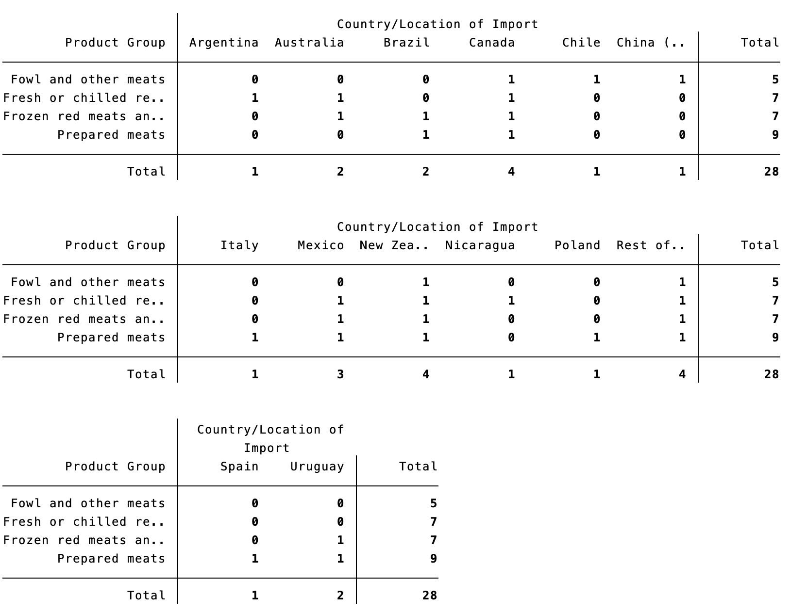

Fish:

**Table of Descriptive Statistics:**

Meat:

|  |
| --- |
| Fowl and other meats: |
| Fresh or chilled red meats: |
| Frozen red meats and parts: |
| Prepared meats: |

Fish:

|  |
| --- |
| Fish fillets and mince: |
| Prepared fish and shellfish: |
| Shellfish, fresh or frozen: |
| Whole fish–fresh, chilled, or frozen: |

**Statistical Hypothesis Tests:**

Two one-way analysis of variance (ANOVA) tests are performed, one for the meat product groups and one for the fish product groups. The null hypotheses of these tests are that means of U.S. meat or fish import values in 2022 are equal by product group. The alternative hypotheses of these tests are that the means of U.S. meat or fish import values in 2022 vary in at least two product groups.

**Summary of Results:**

For the ANOVA test on meat products, the F-statistic is 1.78 and the P-value is 0.1779. For the ANOVA test on fish products, the F-statistic is 2.47 and the P-value is 0.0829. Given the alpha level for both tests is 0.05 and both have P-values greater than that, there is a failure to reject the null hypothesis in both cases. The study concludes that product groups cannot decisively be proven as a factor in the determination of U.S. import values for meat and fish products.

**Limitations:**

The data itself shows limitations in multiple ways. For instance, the listed product groups are not very specific, resulting in broad sets of products being grouped together. Additionally, the import countries are listed as the main value providers for each product group, but only for the top 4-8 values. The countries not in the top 4-8 have their values combined into “Rest of the world” data points.

**Concluding Statement:**

The test results have proven inconclusive in determining if finer product groupings within food groups affected their import values. In spite of this, the P-values for both tests are not extremely far away from the alpha level. This shows that further detailed examination of these groupings with more specific product group designations and more countries listed could provide more insight into whether or not product grouping affects import values.

1. Snell, Will. 2020. “Economic Factors Affecting Agricultural Trade.” https://agecon.ca.uky.edu/files/economic_factors_affecting_agricultural_trade.pdf.
2. Roser, Max, Hannah Ritchie, and Pablo Rosado. 2013. “Food Supply.” Our World in Data. March 5, 2013. https://ourworldindata.org/food-supply.